Graph Theory Fall 2020

Assignment 8

Due at 5:00 pm on Friday, December 11

1. **Let $G$ have Laplacian matrix**
$$L=\left[\begin{matrix}2 & 0 & 0 & -1 & -1 & 0 & 0 \\ 0 & 2 & -1 & 0 & -1 & 0 & 0 \\ 0 & -1 & 3 & 0 & 0 & -1 & -1 \\ -1 & 0 & 0 & 3 & 0 & -1 & -1 \\ -1 & -1 & 0 & 0 & 3 & 0 & -1 \\ 0 & 0 & -1 & -1 & 0 & 2 & 0 \\ 0 & 0 & -1 & -1 & -1 & 0 & 3\end{matrix}\right]$$

2. **Use a matrix calculator to find the eigenvalues of $L$; there should be some pairs of them that have the same value. List them in order**

$$0≤λ_{2}≤λ_{3}≤λ_{4}≤λ_{5}≤λ_{6}≤λ_{7}.$$

$γ_{1 }=5.41421$

$γ_{2}≈ 3.61803$

$γ_{3 }≈3.61803$

$γ_{4 }≈2.58579$

$γ_{5}≈ 1.38197$

$γ_{6 }≈1.38197$

$γ_{7 }≈0$

In ascending order

$γ_{7} < γ_{5} <γ_{6} < γ_{4} < γ_{2} <γ_{3} < γ_{1}$

The diagonal elements are all positive, each containing the degree of the vertex in question. Each of the rows add up to zero. W

1. **Use a matrix calculator to find eigenvectors $v$ and $w$ corresponding to $λ_{2}$ and $λ_{3}$. Compute the vector**

V and W will NOT be orthogonal

$\left[\begin{matrix}2 & & & -1 & -1 & & \\ & 2 & -1 & & -1 & & \\ & -1 & 3 & & & -1 & -1 \\ -1 & & & 3 & & -1 & -1 \\ -1 & -1 & & & 3 & & -1 \\ & & -1 & -1 & & 2 & \\ & & -1 & -1 & -1 & & 3\end{matrix}\right]\left[\begin{matrix}a \\ a \\ a \\ b \\ b \\ b \\ b\end{matrix}\right]$**= $\left|\begin{matrix}2a - 2b \\ 2a-2b \\ -3a + 3b \\ -a + b \\ -2a +2b \\ -a +b \\ -a+ b\end{matrix}\right| =(a-b) \left|\begin{matrix}2 \\ 2 \\ -3 \\ -1 \\ -2 \\ -1 \\ -1\end{matrix}\right|$**

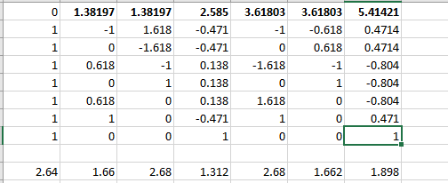

1. **Let $x=\frac{1}{\sqrt{v⋅v}}v$ and $y=\frac{1}{\sqrt{z⋅z}} z$ and plot the points**

$$\left(x_{1},y_{1}\right), \left(x_{2},y_{2}\right), \left(x_{3}, y_{3}\right), \left(x_{4}, y_{4}\right), \left(x_{5},y_{5}\right), \left(x_{6},y_{6}\right), (x_{7},y_{7})$$

**and for each edge $ij$ of $G$, draw the segment joining $(x_{i},y_{i})$ to $(x_{j},y_{j})$.**

**The result in C should be a “nice” drawing of $G$, in the sense that adjacent vertices are close together.**

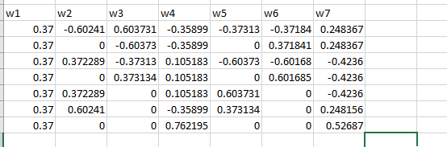

1. **Do the same process in parts B and C for the eigenvectors corresponding to $λ_{6}$ and $λ_{7}$, the two largest eigenvalues.**

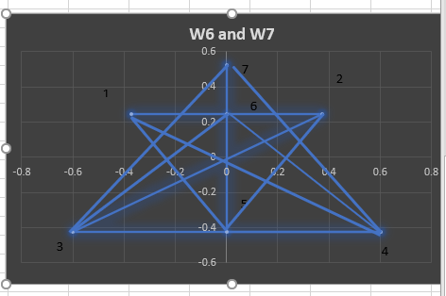

1. **The end result in part D should cause adjacent vertices to be drawn far apart and give you an idea of how to assign colors to the vertices to determine the chromatic number of $G$. What is this chromatic number?**











**Chromatic Number = 3**



1. **Consider the tournament whose adjacency matrix is**

$$T=\left[\begin{matrix}0 & 1 & 1 & 1 & 1 & 0 & 0 \\ 0 & 0 & 1 & 1 & 1 & 0 & 1 \\ 0 & 0 & 0 & 1 & 1 & 0 & 0 \\ 0 & 0 & 0 & 0 & 1 & 0 & 0 \\ 0 & 0 & 0 & 0 & 0 & 1 & 1 \\ 1 & 1 & 1 & 1 & 0 & 0 & 1 \\ 1 & 0 & 1 & 1 & 0 & 0 & 0\end{matrix}\right]$$

**Here, $T_{ij}=1$ if player $i$ defeated player $j$ in the tournament.**

1. **Use software of your choice to compute $T^{2}$, $T^{4}$, $T^{8}, T^{16}$– this is most easily accomplished by squaring the matrix successively, rather than by computing the powers individually.**
$$T^{2}\begin{matrix}0 & 0 & 1 & 2 & 3 & 1 & 2 \\ 1 & 0 & 1 & 2 & 2 & 1 & 1 \\ 0 & 0 & 0 & 0 & 1 & 1 & 1 \\ 0 & 0 & 0 & 0 & 0 & 1 & 1 \\ 2 & 1 & 2 & 2 & 0 & 0 & 1 \\ 1 & 1 & 3 & 4 & 4 & 0 & 1 \\ 0 & 1 & 1 & 2 & 3 & 0 & 0\end{matrix}$$

$$T^{4}\begin{matrix}7 & 6 & 11 & 14 & 11 & 3 & 7 \\ 5 & 4 & 9 & 12 & 11 & 4 & 8 \\ 3 & 3 & 6 & 8 & 7 & 0 & 2 \\ 1 & 2 & 4 & 6 & 7 & 0 & 1 \\ 1 & 1 & 4 & 8 & 13 & 7 & 9 \\ 9 & 5 & 11 & 14 & 11 & 9 & 14 \\ 7 & 3 & 7 & 8 & 3 & 4 & 7\end{matrix}$$

$$T^{8}\begin{matrix}213 & 174 & 379 & 528 & 515 & 177 & 323 \\ 197 & 152 & 337 & 470 & 457 & 176 & 308 \\ 83 & 77 & 170 & 246 & 261 & 78 & 142 \\ 49 & 48 & 112 & 170 & 197 & 64 & 107 \\ 171 & 113 & 268 & 380 & 379 & 197 & 309 \\ 325 & 233 & 507 & 684 & 613 & 261 & 462 \\ 181 & 135 & 283 & 374 & 319 & 118 & 227\end{matrix}$$

$$T^{16}\begin{matrix}341029 & 261078 & 582099 & 814808 & 798871 & 317445 & 546935 \\ 314001 & 240120 & 534689 & 747494 & 730809 & 290296 & 501032 \\ 154695 & 117881 & 263538 & 369294 & 362797 & 145778 & 249906 \\ 111373 & 84224 & 188352 & 263538 & 257921 & 104876 & 179435 \\ 284311 & 216249 & 479908 & 668260 & 647487 & 257921 & 447021 \\ 463993 & 356289 & 791851 & 1106364 & 1080629 & 425253 & 736794 \\ 240949 & 185943 & 413651 & 579046 & 568099 & 222234 & 384863\end{matrix}$$

2. **As you successively square the matrix, the columns should begin to converge to multiples of each other. What is happening is that the columns are converging to multiples of the dominant eigenvector.**

The largest eigenvalue of the matrix T will be 2.5161, and the eigenvector is (1, 0.916, 0.454, 0.325, 0.819, 1.353, 0.707).

Based on the eigenvector above, the player ranking would be $6→1→2→5→7→3→4$.

Any column would be suitable to give the same, above mentioned ranking which supports that the columns of powers(a) of $T^{a}$ are converging to multiples of the dominant eigenvector.

1. **According to the relative values of column entries, how should the participants be ranked?**

The ranking should be $6→1→2→5→7→3→4$. The player in 6th and 4th will be ranked the best and least.

1. **In part C, did you find that any player who won fewer games was more highly ranked than someone who won more games?**

In the above given question, if player i defeats player j, then the equation would be $Tij=1$. Therefore, the row sum of that specific row and determine the number of matches player i won will be,

$$R_{i}=\sum_{1}^{7}{T_{ij}}$$

After computation of the row sums, we get

$$R = ( 4,4,2,1,2,5,3)$$

If we take this, and rank the players solely based on the only the number of matches in which they have defeated the other player, we get the ranking

$$Ranking based on matches won : 6 ,1, 2, 7, 5, 3, 4$$

As the positions of player 7 and player 5 have interchanged, we can deduce that player 7 had won more matches than player 5, therefore, player 5 is the one who won fewer games but was more highly ranked.